Collision and escape, active plate accretion in the North Andes, results from GPS satellite geodesy
James Kellogg
School of Earth, Ocean, and Environment, University of South Carolina, Columbia SC
http://www.AndeanGeophysical.com

Continental margins expand outward and deform by terrane collision and accretion and margin-parallel terrane displacement. With the development of Global Positioning System satellite geodesy, small displacements can be accurately measured along plate boundaries. 28 years of GPS measurements in the North Andes and adjacent oceanic islands provide direct evidence for active accretion and deformation processes along a continental plate boundary. Direct measurements are being made of an arc-continent collision (Panama and the North Andes) and margin-parallel “escape” of the North Andean terranes driven by the subduction of the Carnegie Ridge. We thus have direct space geodesy field evidence for two of the most important modes of continental margin deformation, accretion and lateral displacement.
In 1988, the CASA (Central And South America) GPS experiment began with the first measurements at a convergent plate boundary and the first global civilian tracking network. Now, continuous GPS networks are measuring deformation in Ecuador, Colombia, Venezuela, Panama, and Costa Rica. One surprising result of the CASA measurements is that the North Andes are “escaping” to the northeast at about 10 km/Ma. Geological field evidence suggests that this margin-parallel “escape” only began 2 million years ago. This displacement is driven by the subduction of the submarine Carnegie Ridge (from the Galapagos hot spot) at the Ecuador trench. The subducting ridge is also pushing the Peru Andes southward and has produced great trench mega-earthquakes, including the 1906 _{Mw} 8.8.
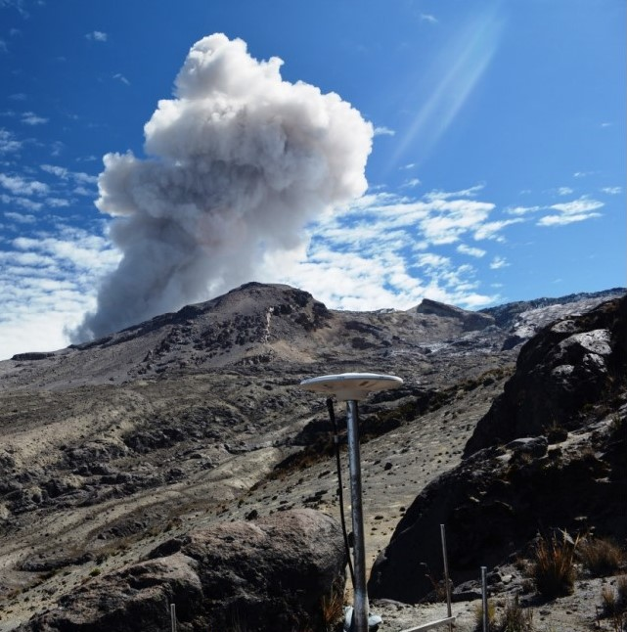

A second CASA discovery is that the Panama arc and the North Andes are colliding at 25 km/Ma. This collision produced a land bridge between North and South America, separated the Atlantic and Pacific Oceans, may have helped bring on the Ice Ages, and formed the Eastern Cordillera mountain range of Colombia (where Bogota is now 3 km above sea level). There is, however, an apparent discrepancy between the small GPS measured shortening in the Eastern Cordillera of Colombia and the apparent recent rapid shortening and uplift of the Cordillera. This apparent discrepancy may be explained with a “broken indenter” model for the Panama arc.

